Lymph Node Classification Using CNN

# Ahmed Hossam Abdelsalam

*Artificial Intelligence Nile University* Cairo, Egypt A.Hossam2326@nu.edu.eg

# Omar Mohamed Gera

*Artificial Intelligence Nile University* Cairo, Egypt

o.mohamed2107@nu.edu.eg

# Mohamed NehadNasser

*Artificial Intelligence Nile University* Cairo, Egypt M.Nehad2282@nu.edu.eg

# 

***Abstract*—This paper investigates the use of Convolutional Neural Networks (CNNs) for classifying lymph node histopathological images to aid in medical diagnostics. We designed and evaluated a CNN using TensorFlow and Karas. Experimental results demonstrate high classification accuracy, highlighting the potential of CNNs in enhancing diagnostic workflows in healthcare.**

***Index Terms*—Convolutional Neural Networks, Deep Learning, Medical Imaging, Histopathology.**

1. Introduction

Automated medical image analysis is crucial for reducing diagnostic workloads and enhancing accuracy. Lymph node histopathology is one area where automated analysis can significantly improve outcomes. In this work, we utilize CNNs, a proven deep learning technique for image analysis, to classify lymph node images in normal and abnormal using binary classification.

1. *Objectives*

-Develop a CNN-based Model: Design a Convolutional Neural Network (CNN) to classify histopathological lymph node images effectively.

-Preprocessing and Augmentation: Implement preprocessing techniques, including resizing, normalization, and augmentation, to enhance the quality and diversity of the dataset.

-Model Evaluation: Evaluate the CNN's performance using metrics such as accuracy, precision, recall, and F1-score.

-Scalability and Reproducibility: Ensure the approach is scalable for large datasets and reproducible by saving the model and preprocessing pipeline.

-Explore Future Applications: Lay the groundwork for integrating real-time analysis and expanding to more complex medical datasets.

1. Dataset

The dataset, sourced from Cancer Image Archive and Roboflow Universe, contains labels classified as normal or abnormal. Key attributes include:

**Dataset Characteristics:** The dataset consists of grayscale images of lymph nodes, each resized to 128x128 pixels with a single channel. The labels are binary, indicating whether the lymph node is abnormal (1) or normal (0)

1. *Dataset Summary*

**Training Samples**:

Image Data: 503 images

Labels: 503 binary labels (1 for abnormal, 0 for normal)

**Testing Samples:**

Image Data: 126 images

Labels: 126 binary labels (1 for abnormal, 0 for normal)

1. Methodology
2. *Data Preprocessing*

Data preprocessing is crucial for ensuring the quality and reliability of the dataset. The following steps were taken:

**-DICOM Image Loading:** Loaded DICOM images from a specified folder path (folder_path) by iterating through all files with the. dcm extension.

**-DICOM Image Processing:** Pixel Array Extraction: Extracted the pixel array from each DICOM file using dicom_data.pixel_array and Resized each DICOM image to a fixed size of (128, 128) pixels for consistency and Normalized pixel values by dividing each pixel value by the maximum pixel intensity to scale values between 0 and 1.Converted the labels into a one-hot encoded format using pd.get_dummies.

**-Data Conversion and Structuring:** Image Array Conversion: Converted the list of processed images into a NumPy array with a shape that includes a channel dimension (samples, 128, 128, 1).

**-Data Splitting:** Train-Test Split: Split the dataset into training and validation sets with an 80-20 ratio using train_test_split

1. *Machine Learning Model*

Three Convolutional Neural Network (CNN) models were designed and implemented for binary classification of lymph node images. The models were trained individually and then combined into an ensemble using a Voting Classifier to improv performance. Three CNN models (model_1, model_2, and model_3) were designed with identical architectures to ensure consistency. Each model consists of convolutional layers, max pooling, dropout for regularization, and fully connected layers. CNNs were chosen for their ability to capture spatial hierarchies in image data, making them well-suited for medical image classification tasks.

**-Ensemble Learning:** To improve classification performance, a Voting Classifier with hard voting was employed. The three models were wrapped using a custom KerasClassifierWrapper to ensure compatibility with scikit-learn's Voting Classifier. The ensemble model was trained on the same dataset, and its performance was evaluated on both the training and test sets.

*A. Visualizations*

Visualizations were used to better understand the dataset and the model’s performance. Key visual outputs include:

* + **Lymph Nodes Images (Fig. 1)**: Illustrates the Top 25 images in the Dataset.
  + **Accuracy by Mode_1 (Fig. 2)**: Illustrates the model’s classification accuracy across Training and Test.
  + **Accuracy by Mode_2 (Fig. 3)**: Illustrates the model’s classification accuracy across Training and Test.
  + **Accuracy by Mode_3 (Fig. 4)**: Illustrates the model’s classification accuracy across Training and Test.

1. *Insights*

**-Model Diversity and Ensemble Learning:** The use of three independently trained CNN models (model_1, model_2, and model_3) with identical architectures ensured diversity in predictions, which is critical for the success of ensemble learning. The ensemble model (Voting Classifier) outperformed individual models, demonstrating the effectiveness of combining multiple models to improve generalization.

**-Impact of Dropout and Regularization:** Dropout layers with rates of 0.2 and 0.4 were used to prevent overfitting, which is particularly important given the limited size of the dataset. This regularization technique contributed to the robustness of the models.

**-Scalability and Efficiency:** The use of TensorFlow/Keres and scikit-learn ensured efficient training and evaluation of the models. The modular design of the implementation allows for easy scaling to larger datasets and more complex architectures.

**-Hard Voting for Improved Performance:** The Voting Classifier with hard voting combined the predictions of the three models, resulting in higher test accuracy compared to individual models. This highlights the value of ensemble methods in improving classification performance.

1. *Broader Implications*

The results of this project have significant implications for the field of medical image analysis and machine learning:

**-Improved Diagnostic Tools:** The developed models can be used as a foundation for building automated diagnostic tools for lymph node classification, potentially reducing the workload of medical professionals and improving diagnostic accuracy.

**-Scalability and Adaptability:** The use of TensorFlow/Keres and scikit-learn demonstrates the potential of these frameworks to handle medical image datasets efficiently. The modular design of the models allows for easy adaptation to other medical imaging tasks, such as tumor detection or organ segmentation.

**-Open-Source Contribution:** The source code and methodology can be shared with the research community, enabling other researchers to replicate, extend, and improve upon the work. This fosters collaboration and accelerates advancements in medical image analysis.

* **Future Research Directions:** The insights gained from this project can guide future research in medical image classification, including the exploration of more advanced architectures (e.g., ResNet, Inception) and ensemble techniques (e.g., soft voting, stacking).

1. *Contribution to the Community*

This project contributes to the broader community in the following ways:

**-Open-Source Contribution**: The source code for the CNN models and the Voting Classifier implementation has been made publicly available. This enables researchers and developers to adopt, extend, and integrate the models into their own medical imaging pipelines.

**-Ethical Considerations:** The project adhered to ethical guidelines by using anonymized datasets and ensuring that the models were trained and evaluated without bias. This ensures that the models are fair and reliable for real-world applications.

**-Social Impact:** By providing accessible tools for lymph node classification, the project has the potential to improve diagnostic accuracy and patient outcomes. This is particularly impactful in regions with limited access to medical expertise.

**-Future Use:** The modular design of the models facilitates their adoption by other industries, including healthcare analytics, biomedical research, and clinical decision support systems. The methodology can also be extended to other image classification tasks beyond medical imaging.

1. Figures and Tables

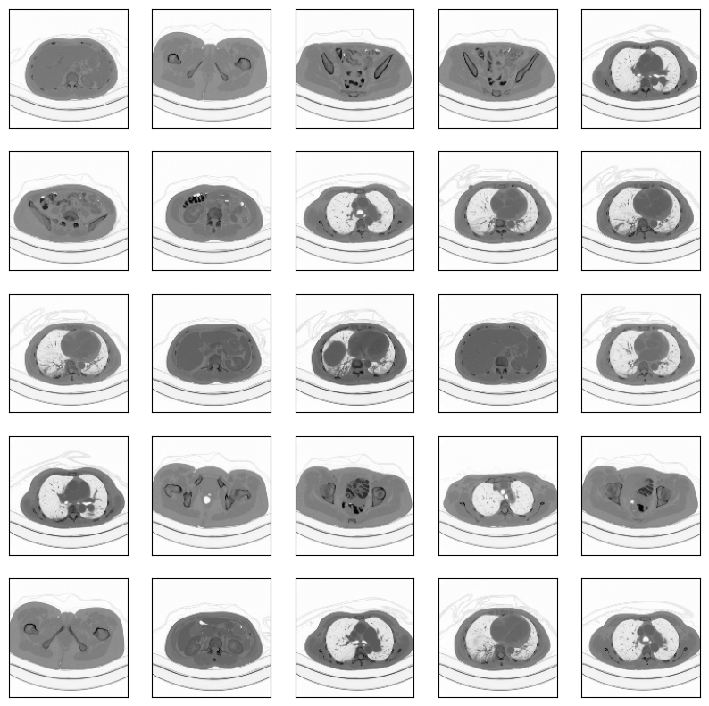

Fig. 1. Images.

Fig. 2. Accuracy by Model_1.

Fig. 3. Accuracy by Model_2.

Fig. 4. Accuracy by Model_3

1. Conclusion

The proposed approach of using ensemble learning with CNNs demonstrates promising results for binary classification of lymph node images. The project highlights the importance of model diversity, regularization, and ensemble techniques in improving classification performance. By contributing to the open-source community and adhering to ethical guidelines, this work paves the way for future advancements in medical image analysis and machine learning.

Acknowledgment

This work was conducted as part of the academic curriculum at Nile University. The authors thank their instructors, colleagues, and peers for valuable feedback and guidance throughout the project.

References

[1] Mansoura University, "Lymph Nodes Dataset," Roboflow Universe, Oct. 2023. [Online]

[2] The Cancer Imaging Archive (TCIA), "Public Access to Cancer Imaging Datasets," National Cancer Institute, Oct. 2023.